Rest Cure
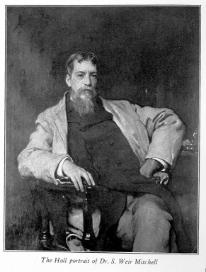

Silas Weir Mitchel, inventor of the rest cure.
Wellcome Library, London

Influential American neurologist Silas Weir Mitchell developed the rest cure in the late 1800s for the treatment of hysteria, neurasthenia and other nervous illnesses. It became widely used in the US and UK, but was prescribed more often for women than men. It was frequently used to treat anorexia nervosa. The treatment did keep some patients alive and others out of asylums, though some patients and doctors considered the cure worse than the disease.

The rest cure usually lasted six to eight weeks. It involved isolation from friends and family. It also enforced bed rest, and nearly constant feeding on a fatty, milk-based diet. Patients were force-fed if necessary - effectively reduced to the dependency of an infant. Nurses cleaned and fed them, and turned them over in bed. Doctors used massage and electrotherapy to maintain muscle tone. Patients were sometimes prohibited from talking, reading, writing and even sewing.

Mitchell believed the point of the rest cure was physical and moral. It boosted the patient’s weight and increased blood supply. It also removed the patient from a potentially toxic social atmosphere at home. However, the implicit point was the neurologist breaking his (almost always female) patient’s will. Some outspoken and independent women received the rest cure. These included writers Virginia Woolf and Charlotte Perkins Gilman. They reacted fiercely against the treatment and doctors practicing it, and wrote about the experience. Later feminist scholars argued the rest cure reinforced an archaic and oppressive notion that women should submit unquestioningly to male authority because it was good for their health.

Bibliography

J Allen, The Feminism of Charlotte Perkins Gilman: Sexualities, Histories, Progressivism (Chicago: University of Chicago Press, 2009).
J Oppenheim, ‘Shattered Nerves’: Doctors, Patients, and Depression in Victorian England (Oxford: Oxford University Press, 1991).

