How to access the media center databases
When you are at the Buford High School web page, select the media center tab. Once you are at the media center web page select the Collect option. This will bring up the databases. Choose your area of interest. The password for the Gale databases is buford. If you are using GALILEO databases, the password will be available in the media center. The GALILEO password changes every three months.
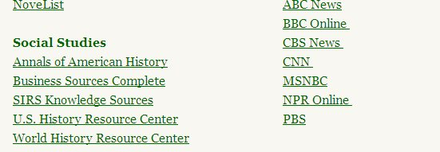

Type what you’re researching in the search box.
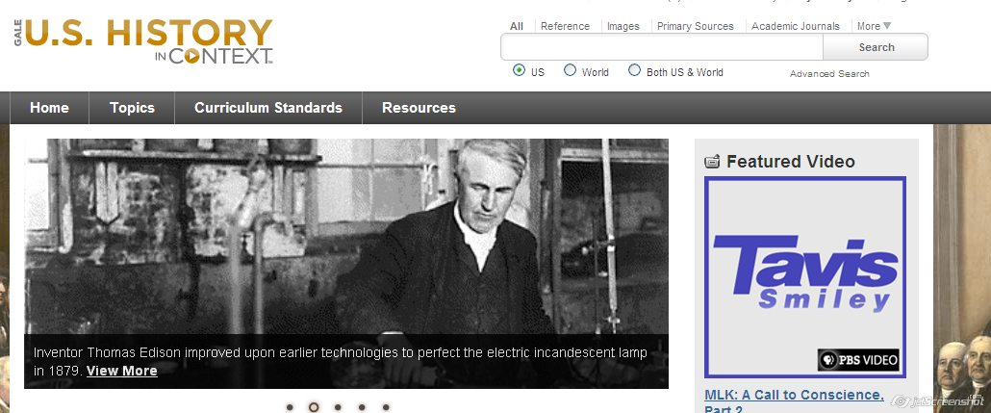

I chose the Jacksonian Democracy. You can see there are 47 different References, 9 Academic Journals, 6 News Paper and 2 Magazine articles.
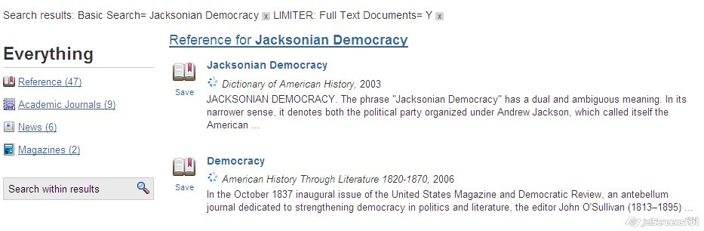
Once you have found what you want to use, the citation is fairly easy. You can copy the information to a Word document, or use http://www.bibme.org/
